Margot MILLET
Born in 1995, Margot Millet is a French photographer, image researcher and graphic designer based between Marseille, Arles and Paris. She is interested in visual culture and modes of representation through various media (advertisement, internet, tourism cultures). Her work combines graphic research, narration, and iconography, and explores the different spaces of representation. Iconographic research plays a major role in her creative process: She compose with archive images — photographs, engravings, ex-libris — or images made by herself. Her artistic projects mix texts and images in various visual supports such as posters, publications, installations and everyday objects.
@margot.millet

Ju BOURGAIN
Ju Bourgain is a French performance and video artist based in Marseille, whose practice also includes poetry. Their performances explore community as both a site of struggle and celebration, inviting the public to experience the power of the collective through dance, music, and contemplation. « The soundtrack, generally techno, like the pulse of a generation alienated from the neo-liberal world, undercuts the binary order. In short, a subtle blend of urgency and vulnerability that keeps us on the edge of our seats. It's about love. » (Céline Point for NONFICTION)
@uniteton

Léa NANA
Léa lives and works in Marseille and wherever else she can dream. She loves composing with the genius loci of a place, creating poetry from what she observes, listening and gleaning from the place itself, creating a dialogue between her environment and spirits who live there.
@lea.nanana

HaYoung
Storyteller, HaYoung seeks to transgress the cultural, political and linguistic boundaries through which they move, blending personal voices with collective memories. Navigating in-between, they dissect physical and digital societies to create new forms of storytelling through rhizomatic installations. After their Masters degree from Villa Arson Nice in France, they continue their research in Jan van Eyck Academie in Netherlands. Their work has been presented at Frac des Pays de la Loire, Ferme du Buisson, Fondation Ricard, Mécènes du Sud, cipM, Het Nieuw Institute, and the International Short Film Festival in Oberhausen.
@high_____five

Curators

Cleo VERSTREPEN
Cleo Verstrepen is a curator and researcher based in Tokyo. They are PhD student at the University of Vincennes Saint-Denis (Paris VIII) and Tokyo University of the Arts, with the support of the MEXT scholarship. Their thesis focuses on community-led art organisations involved in rural and urban revitalisation processes in Japan. Their approach to research is creative and integrative, extending beyond the academic sphere through artistic, curatorial, and literary practices. They are a founding member of the collective-run art space Datsuijo in Tokyo.
@kureopi_

LI Jingwen (Seibun)
Li excels in various fields as an artist, curator, and researcher, bringing a multidimensional perspective to contemporary art. Currently, she's deepening her research on sculpture in digital fields, focusing on the social aspects of sculptural bodies and spaces, while enrolled in the doctoral program at Tokyo University of the Arts. She also manages the art organization team 'Upload AIR,' which prepares an artist in residency space ' D-O-U narimasu' in Narimasu Tokyo. She actively participates in the global art collective 'Datsuijo.'
@lijingwen_art

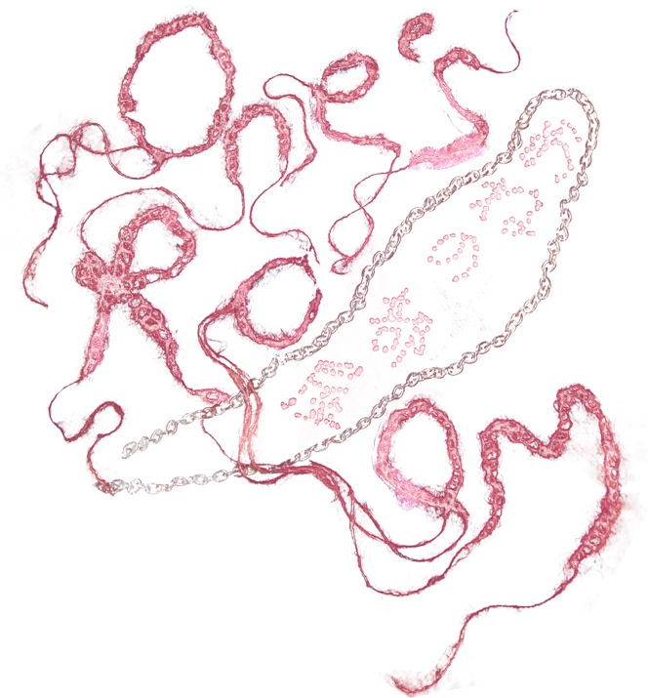

Emese PAP
Emese Pap is an artist whose practice is transversal, linking tapestry, writing, sound creation and painting. Her work illustrates various notions of nomadism, displacement, change of scale, metamorphosis and dissidence. Of Hungarian origin, she lives and works in the South of France since 2016.
@felix_emese_pap

Garance FRUH
In her sculptural practice, Garance Früh (born in 1992) recontextualizes everyday objects with seemingly contradictory attributes. For instance, masculine-associated sports equipment is combined with childcare protective items, delicate fabrics, and fragile ceramic objects to form new kinds of shells and armors. Her works reflect existing systems of oppression while consciously avoiding dichotomous classifications: sensitivity and gentleness become defensive and emancipatory attributes. Garance Früh is graduated from the Gerrit Rietveld Academie (Amsterdam) and the ENSAPC (Cergy). Her work have notably been shown at BQ Gallery, Forde, In extenso, FRAC Pays de La Loire, Fondation Pernod Ricard, FRAC Île de France, and at the Reiffers Art Initiatives Prize.
@garance.fr

Yutaro SUDO
Sudo mainly creates small objects. They uses various materials like ready-made items found at home, fragments picked up outside, and even things like nails, hair, and dead bodies. Sometimes, they also makes videos or books. The way their works changes depending on the project. By making many things, Sudo is trying to deepen their understanding of others and life.
@sudoyutaro

JACKSON kaki
Born in 1996 in Shizuoka Prefecture, currently enrolled at the Institute of Advanced Media Arts and Sciences. Active as an artist, DJ, VJ, video artist, and graphic designer. Works with multimedia including VR/AR, 3DCG, video, performance, installation, and sound, focusing on the natural aspects of the body and the concept of virtual reality through production and research. Also active as a director and curator of art projects. In 2022, used the Shibuya club 'CONTACT' for the art project 'Imaginary Line'. In 2023, co-curated the Video/Sound/Performance program at EASTEAST_TOKYO with QIUYU JIN, and served as the director of 'ZOR' held at CALM & PUNK GALLERY.
@kakiaraara

Rozy SAPELKINE
Rozy Sapelkine, born in 1996, is a multidisciplinary artist and craftperson: bead-maker, set designer, and costume designer. They graduated from the École Duperré, Design et métiers d'Art (Paris) and the Gerrit Rietveld Academie (Netherlands). Interweaving the practice of aesthetics and composition, Rozy's work uses the term "make up" to link transformation and the construction of history. Driven by a desire to augment the body, to expand the self on stage and to transmit, Rozy gives life to spaces of transfiguration which, thanks to the research that goes into each project, become committed aesthetic manifestos. Rozy performed for the first time at Treize (Paris), their work has been exhibited at Confort Moderne (Poitiers) and SISSI (Marseille) and will soon be on show at La Cité des Arts (Ile de la Réunion).
Ricard, Mécènes du Sud, cipM, Het Nieuw Institute, and the International Short Film Festival in Oberhausen.
@rozykine

Ching-Chuan KUO
Ching-Chuan Kuo (born in Taiwan, 1995) draws inspiration from his surroundings, such as intimate relationships with others, objects and accustomed actions in our daily life, with a touch of intimacy and humour. He uses paintings, photograph, daily life objects and written words as his materials for art.
@kuochingchuan

Johanna RIEDL
Johanna Riedl is a multimedia artist engaging with the realms of video, sound, and installation, where the performative aspect of her work transcends mere interaction within the scope of technology in social contexts. The sculptural bodies are not inert; they are animated, breathing components of a collective consciousness, each piece recognized as a fragment of a larger, interconnected dialogue — a conscious state in constant formation during an ongoing understanding of the symbiotic relationship between technology and human experience.
@jo____hansi

Masato NAKANO
Born in 1996, graduated from Kyoto Seika University. He creates works in various forms including painting, ceramics, aquariums, spray painting, and tattoos. During his teenage years, he had many encounters with Christianity, often interpreting and using descriptions and concepts from the Bible as motifs in his work.
@nakanomst

Ix DARTAYRE
Based in Marseille (France), Ix’s productions are plural. They invoke a variety of practices, subjects, bodies, or histories, and participate in multiple spaces while playing with different scales and levels of reading. The images at the heart of their work are always the result of an encounter, a dialog or a particular relationship with the people photographed. For the artist, these images represents both personal memories, full of intimacy and affect, and the basis for a larger artistic body of collaborative, visual work.
@xdartayre

Cally TAN
Graduated from Tama Art University with an MFA in Textile Design. Cally’s practice is founded on notions concerning sublimity in simple things and reevaluating significance in non-human existences. To unpack these concepts, Cally employs fibre materials and textile-centric techniques—entities she believes embody “otherness” to the human agency, to create artworks. Ranging between playful sculptures and spacious installations, her works maintain familiarity, prompting viewers to resonate with them emotionally and ideologically.
@soberfeelz

Clovis DESCHAMPS-PRINCE
Clovis Deschamps-Prince works with(in) landscapes. He hikes, camps, gleans plants and clay and tries new gestures and protocols to connect with nature. Using crafts such as ceramics or natural dye his sculptures are charged with emotions. Through his practice Clovis tries to weave a loving relationship to his surroundings, especially the landscapes of Provence where he lives. To make these experiences collective, the public is invited to inhabit shelters, to share food, drinks, stories and rituals that nourish our bodies and minds.
@cdeschamps_prince

Albane MONNIER
Albane Monnier (born in 1993), graduated from the École Nationale Supérieure des Arts Décoratifs (Paris), develops a protean practice (videos, objects, textiles, printed editions, drawings) with language as the common thread. Using economical, domestic, and accessible materials in a "house practice", she explores our intimacies. Her work is influenced by various references, ranging from women's magazines to sociology, from modernist avant-gardes to DIY tutorials, from medieval literature to cut-up techniques, and includes cinema.
@albane__monnier

Ava NABA
Ava Naba is a card reader, artist, and magnetizer. Although distinct in appearance, these three realms constantly overlap and clash, fueling their reflections and research, giving rise to curious hybridizations and new forms of expression. The mediums they use to create these chimeras include painting, drawing, installation, recycled objects, and more recently, performance. The idea behind each work is to offer the viewer surfaces for reflection for their imagination and to create atmospheres conducive to introspection.
@ava.nabaa
@scorpion.bleu

Yuto NEMOTO
Born in 1992 in Chiba Prefecture. Graduated from the Doctoral Program in Sculpture at Tokyo University of the Arts in 2023. Major solo exhibitions include “People” at A-Soko in Higashi-Kasai, 2024; “Nothing At All” at Token Art Center, 2021; and “Perfect Office” at AOYAMA studio164, 2020. Awards include selection for the Gunma Youth Biennale in 2021 and the Grand Prize at CAF in 2018. Nemoto also operates his home, “Soft House Minowa,” as an artist-run space.
@new_shit_president

Theophylle DCX
Born in 1996, Théophylle Dcx lives and works in Marseille. His artistic practice mixes poetic writing, performance and video. Empowerment through collective celebration, connection to others, the power of words, and the possibilities and limits of the body are all subjects that run through the devices. His work deals with the body as an archive and the embodiment of a political gesture, on which appear the flow of history, the stakes of social struggles and the need for emancipation from contemporary normative regimes.
@theophylle.dcx

Niko WU
Niko Wu is a Tokyo-based artist who is constantly exploring new ways to express herself through various mediums. In her photography, she directs, designs sets, and captures images on 35mm film. Beyond exhibitions, Niko contributes visual content to platforms and editorials such as IWAKAN magazine, NYLON, i-D, Avant Arte, and others. In her three-dimensional works, she experiments with ceramics, textiles, drawings, and vintage (waste) materials to create objects and mixed-medium works that evoke a poetic sensibility.
@nikoful

